**Devops:**

CI/CD is the devops

CI-Continuous Integration is where the developer writes the code and continuously pushed to the version control system which is automated to test build and create the Articrafts instead of where developer code and push the code to version control system not continuously whenever he does changes which gives a lot of errors

[defect errors at very earlier stage]

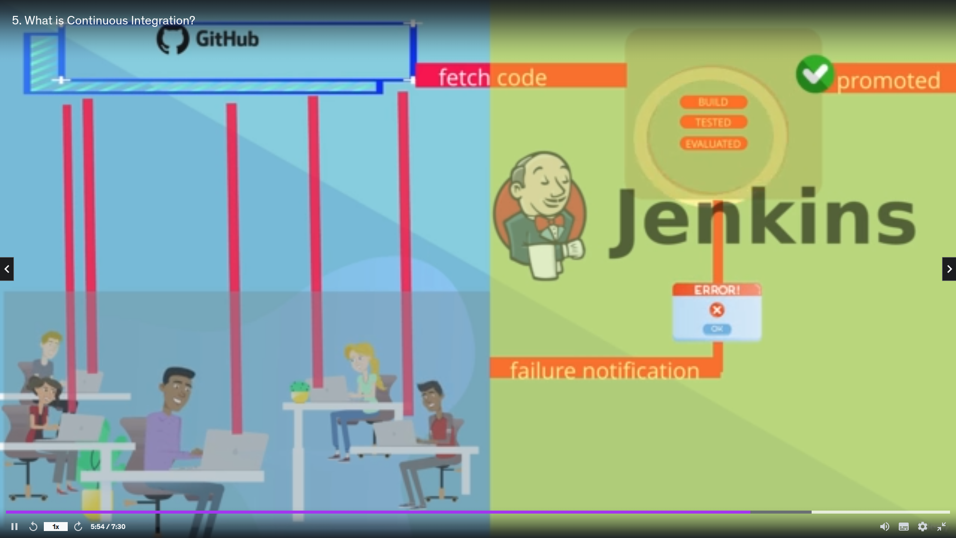

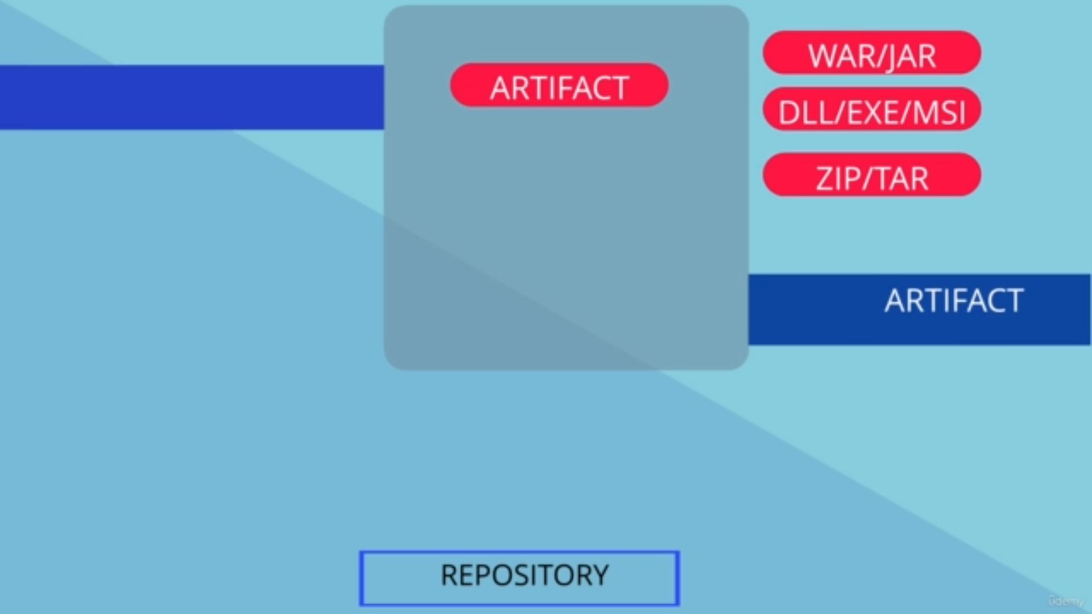

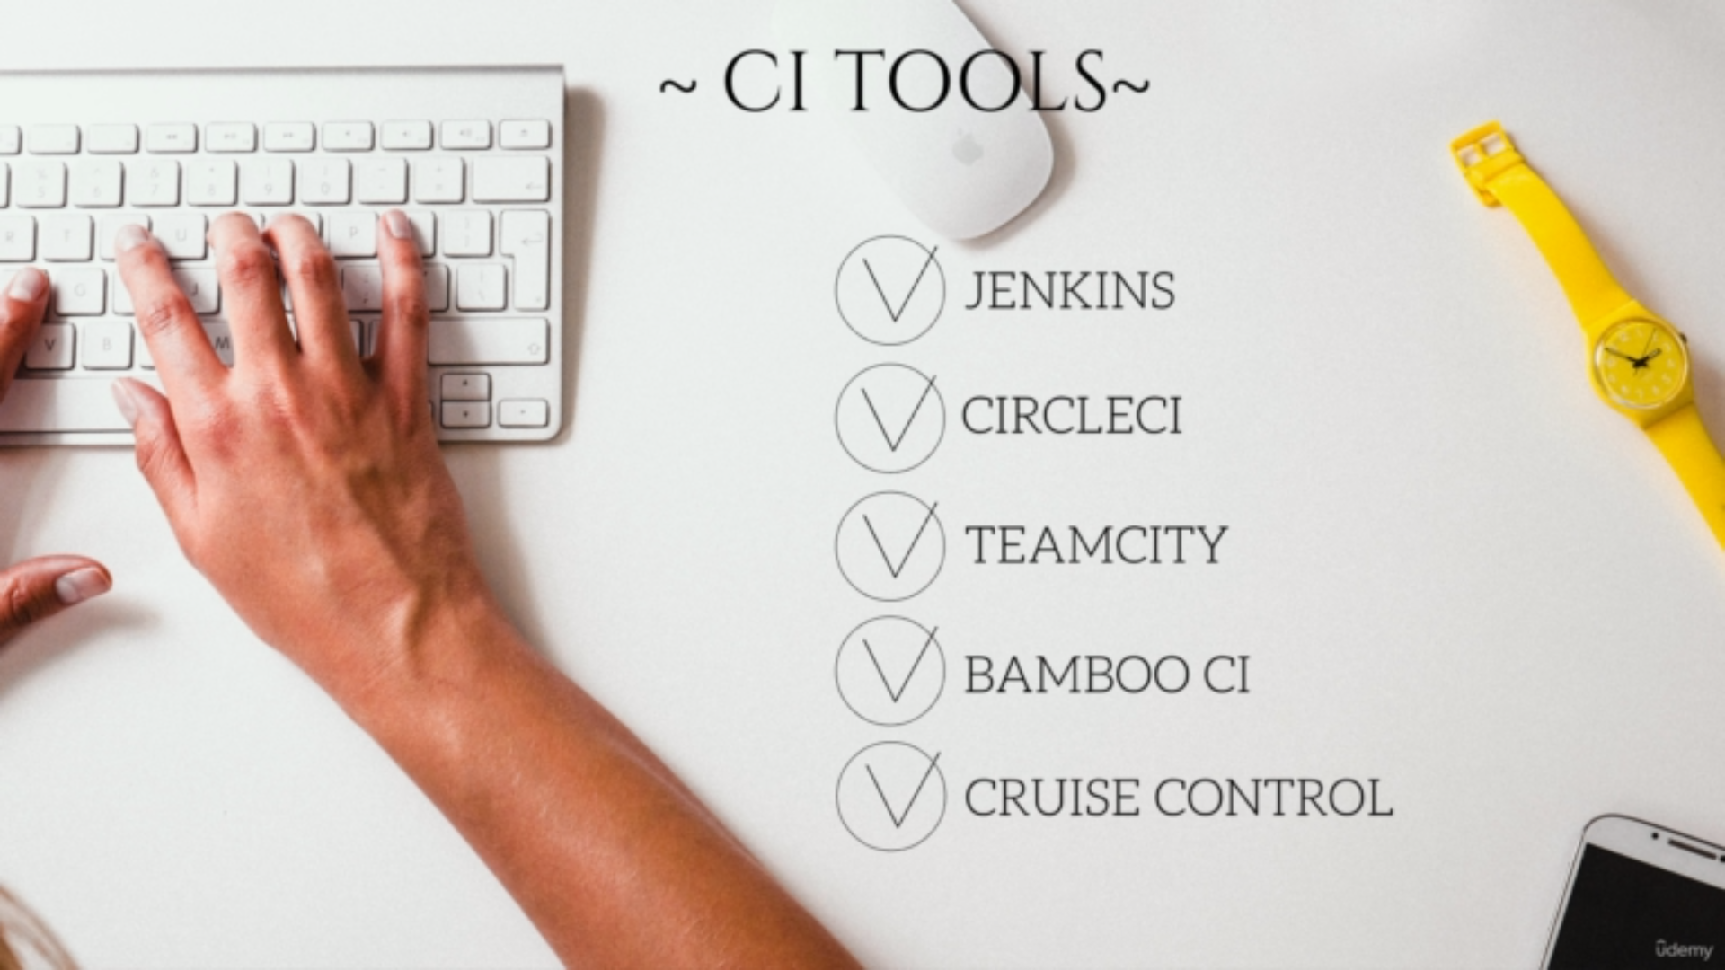

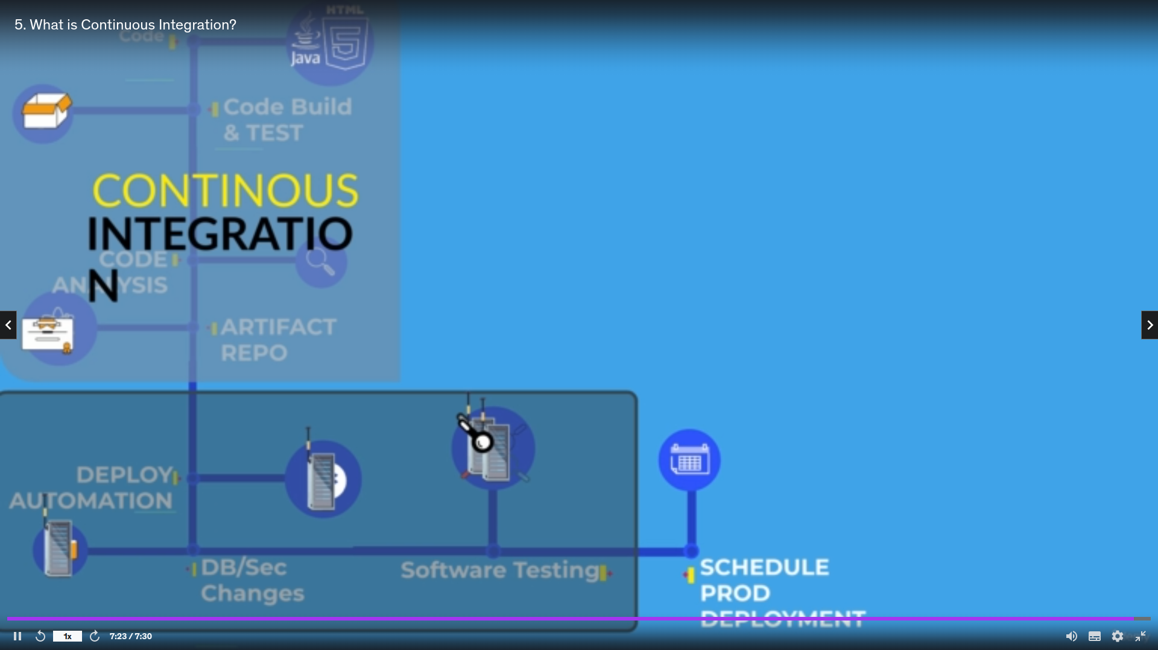

CD-Continuous Delivery is where the Articrafts which are developed by the continuous integration are deployed to test the product with required configuration,dependecies,serverand firewall changes and credentials etc and sent to the production and this process is also automated

